What is an FPX File?
The main purpose of an FPX file is to store component package dimensions and the component manufacturer's data. Here is a list of 9 attributes items that are default with the PCB Library Expert -
- Component Family (auto-generated but not a visible column in the FPX editor)
- Component Dimensions (auto-generated but not a visible column in the FPX editor)
- Footprint Name (auto-generated by the Library Expert)
- Physical Description (auto-generated by the Library Expert)
- Case Code (component manufacturer's ID of the package)
- Manufacturer (component mfr. company name)
- Part Number (manufacturer's Logical part number)
- Logical Description (component manufacturer's logical description)
- Datasheet (http:// web-link or network drive link + PDF file name)
- Items 1 - 4 are auto-generated
- Items 5 - 9 are inserted by the end user (used as search criteria to locate existing parts).

The PCB Library Expert User can add as many attribute columns as necessary. Some of the most popular additional columns are "Revision or Version Control", "Supplier Name and Part Number" (Digi-Key), "Schematic Symbol Name", "Created By and Date", "Corporate Part Number" and so on.
The FPX file does not contain any user rules or footprint dimensions. It is important that the Library Expert end user knows that the main item to generate a footprint are the component family and component dimensions. This means that you cannot import your existing CAD tool library into an FPX file.
The User Preference Rules are applied to the component family and component dimensions to auto-generate a Footprint pattern for the PCB library.
The component family and dimensions is stable data that never changes. So the User can continuously add new component dimensions to the FPX and never have to go back and change anything.
The User Preference Rules are continuously changing as manufacturers continue to improve their processes. So at any time, the Library Expert User can make a change to their Preference Rules and run all their component dimensions through those new rules and create a new library. So the Library Construction Rules may change at any time, but the FPX file never changes except to continually add additional package data.
There is no limit of how many parts can be put in an FPX file, but certain features are slow if the FPX file gets too big. To achieve maximum software performance, we recommend not exceeding 3,000 parts in an FPX file.
Here is a sample FPX file loaded in the Library Expert FPX Editor -
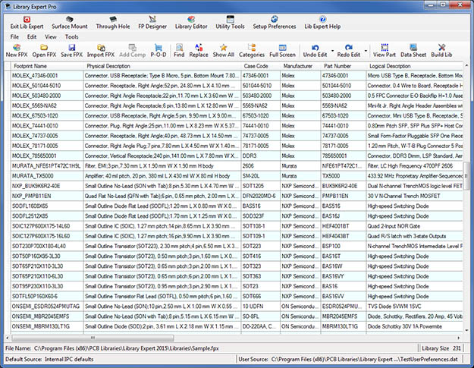
The column data that the User inserts comes directly from the component manufacturer Logical datasheet.
Using this Texas Instruments datasheet as an example, the number in the upper right corner is the "Logical Part Number" and the text below the part number is the "Logical Description".
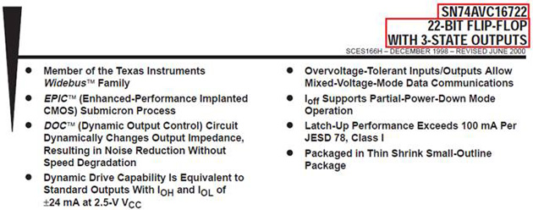
Included in the Logical datasheet are the component dimensions.
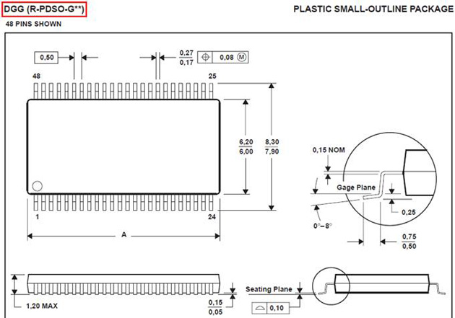
The component manufacturer uses a code to identify the package. In this Texas Instruments datasheet, the "Case Code" is located in the upper left corner.
The sample Datasheet URL is http://www.ti.com/lit/ds/symlink/sn74avc16722.pdf and includes both the Logical and physical data for the electronic device.

